CenPOS users and details
https://webstaging.cenpos.net/vt
MID: Associated Spring Raymond UAT, 790010234
Administrator User ID: Admin
Password – Jul-29-2025: K91xwKLc6wDKneg3BMRT@
Prior Password: 256IwAqOsU-o
Integration User ID: Infortest
Integration User Password – Jul-29-2025: SGi5sWQkGvvoQqH95ldF@
Prior Integration User Password: Cenpos@12345

MID: 790007439 [DECOMISSIONED DUE TO ISSUES]
DBA: Associated Spring Raymond TEST
User: Admin
PW-Jul-2025: X7rb4yhggrTIoCLTp7vc@
PW-Jun-2025: woaSbxPrOVbvo7%KKYul
PW-Mar-2025: FR1j@nKPiuOD9EgX0YE4
PW-Feb-2025: ANvg8efsRtaoMSmC9ypp@
PW-Jan-2025: NNp7aP9XSxT44ERSwufO$
PW: 4KAI6D6zV4OTWX5npGIL#
Prior PW: hdzYP7aZ6DPK6y76YnAR@
User: Infor
PW: BbVKGtZMX3ZH2dj#

User for SIT
User: ASR_M3_Service
PW-Jul-16-2025: nVeqlpBDksesKnbSo3A8#
PW-Jul-2025: p4yp6cgly5iKpLQpDHPu$
PW-Jun-2025: KgLNq7KFC76@B74IH65o
PW-Mar-2025: es#SUyx9@dqJ9qMGc4gh
PW-Feb-2025: nVfSdlRIexxwR4JnYfFk#
PW-Jan-2025: 9WdprsNOErUn8olXtoEc%
PW: ASR_Cenpos_SIT241202
Prior PW: ASR_Cenpos_SIT241111
Url: https://webstaging.cenpos.net/posintegration/posintegration-html5/
Host: https://abistaging.cenpos.net/6/transact.asmx?wsdl

Virtual Terminal: https://webstaging.cenpos.net/vt
Cashiering: https://webstaging.cenpos.net/cashiering-html5/
POS Integration: https://webstaging.cenpos.net/posintegration/posintegration-html5/
EBPP: https://webstaging.cenpos.net/EbppAdmin/
processor host site is: http://hubstaging.cenpos.net/

SWP:
SiteVerify:
https://webstaging.cenpos.net/simplewebpay/cards/?app=genericcontroller&action=siteVerify
UseCrypto:
https://webstaging.cenpos.net/simplewebpay/cards/api/UseCrypto/
ConvertCrypto:
https://webstaging.cenpos.net/simplewebpay/cards/api/ConvertCrypto/
Force:
https://webstaging.cenpos.net/simplewebpay/cards/api/Force/
GetToken:
https://webstaging.cenpos.net/simplewebpay/cards/api/GetToken/
UseCrypto :
https://webstaging.cenpos.net/simplewebpay/cards/api/UseCrypto/

Webservices:
TransactionalWebService Service (cenpos.net)
AdministrationWebService Service (cenpos.net)
CheckWebService Service (cenpos.net)
https://abistaging.cenpos.net/5/tokens.asmx

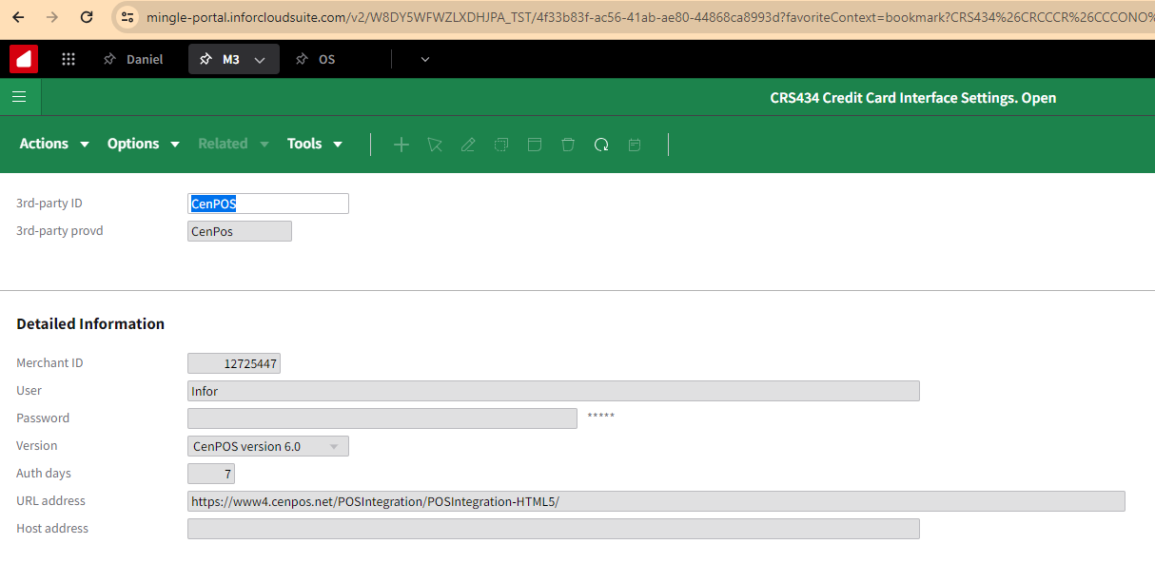
TST910 2024-10-31
CRS434
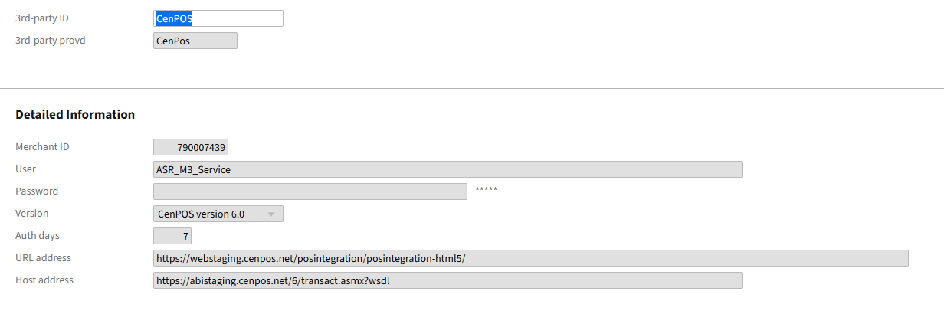
CRS439
